Ideation Phase
Empathize & Discover

Date | 07 March 2026
Team ID | Sumit Yadav, Bipin Kole, Sagar Shrikant, Vaishnavi Khot
Project Name | Plugging into the Future: An Exploration of  Electricity Consumption Patterns Using Tableau
Maximum Marks | 4 Marks

Empathy Map Canvas:
An empathy map is a simple, easy-to-digest visual that captures knowledge about a user’s behaviours and attitudes.

It is a useful tool to helps teams better understand their users.
Creating an effective solution requires understanding the true problem and the person who is experiencing it. The exercise of creating the map helps participants consider things from the user’s perspective along with his or her goals and challenges.
Example:
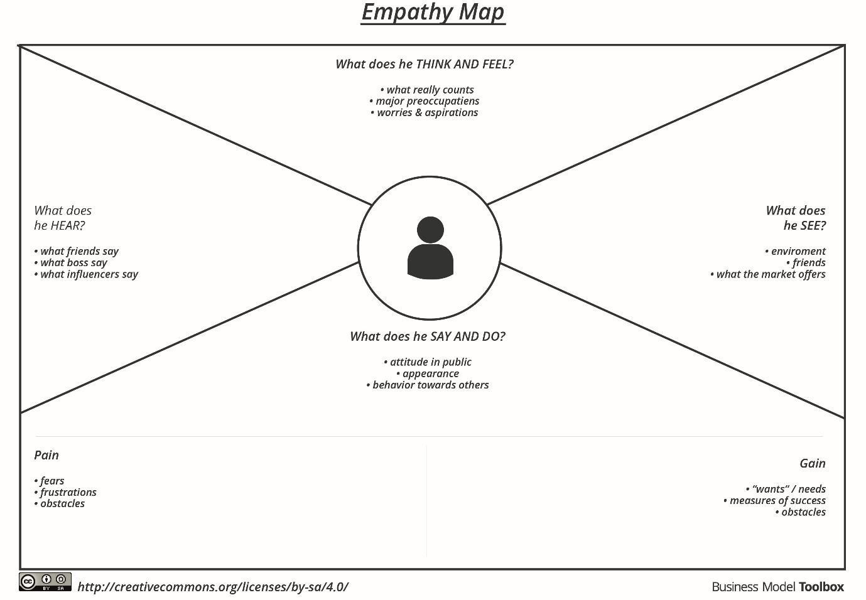

Reference: https://www.mural.co/templates/empathy-map-canvas

Example: Food Ordering & Delivery Application
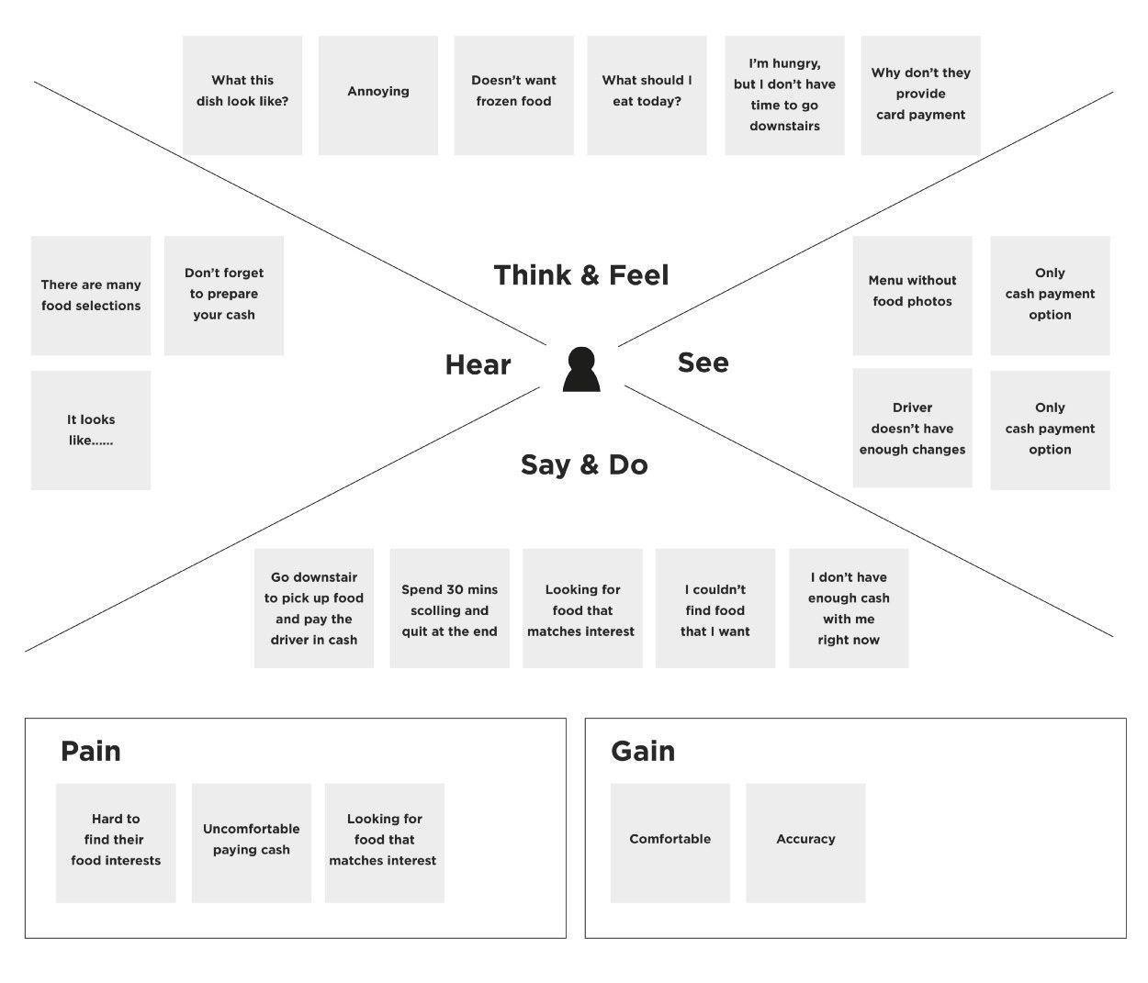
Empathy Map Elements (from the Mural reference)
We’ll structure the empathy map based on these standard quadrants:
- Says – What the user says out loud in interviews or observations
- Thinks – What the user is thinking or concerned about
- Does – Actions the user takes
- Feels – Emotional experience and attitudes
- Goals – What they want to achieve
- Pains – Frustrations, challenges, or blockers

